AIO testing ---- draft status means only assigned owner can see it

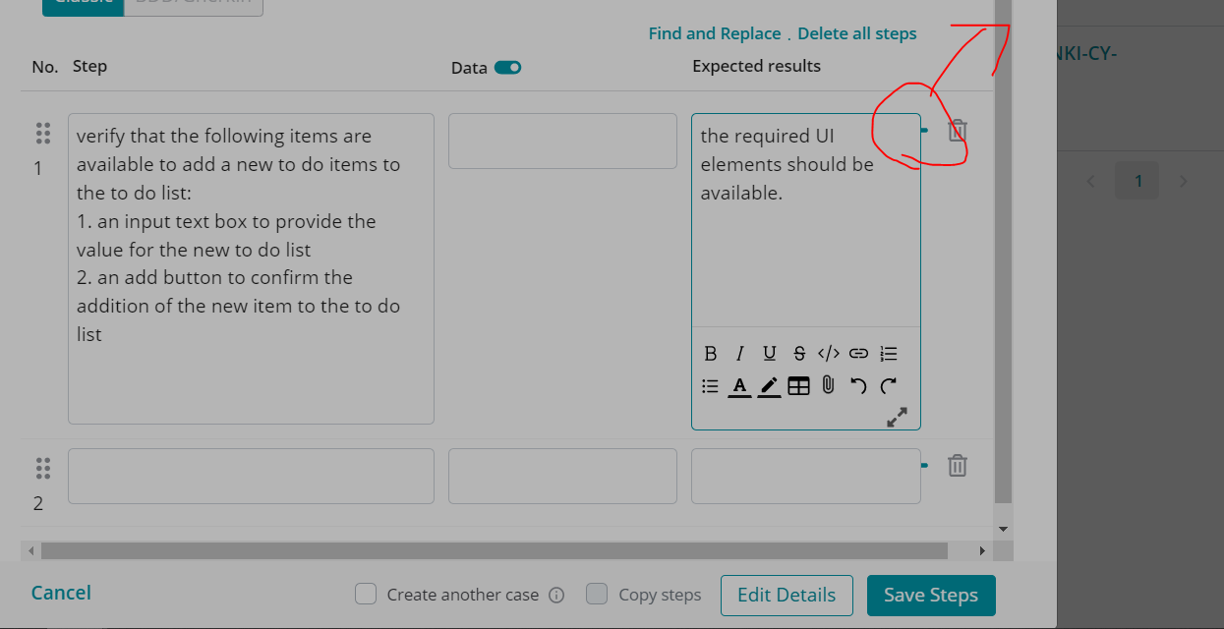”+” sign to add steps

Now go to issues and create test case in AIO for every story

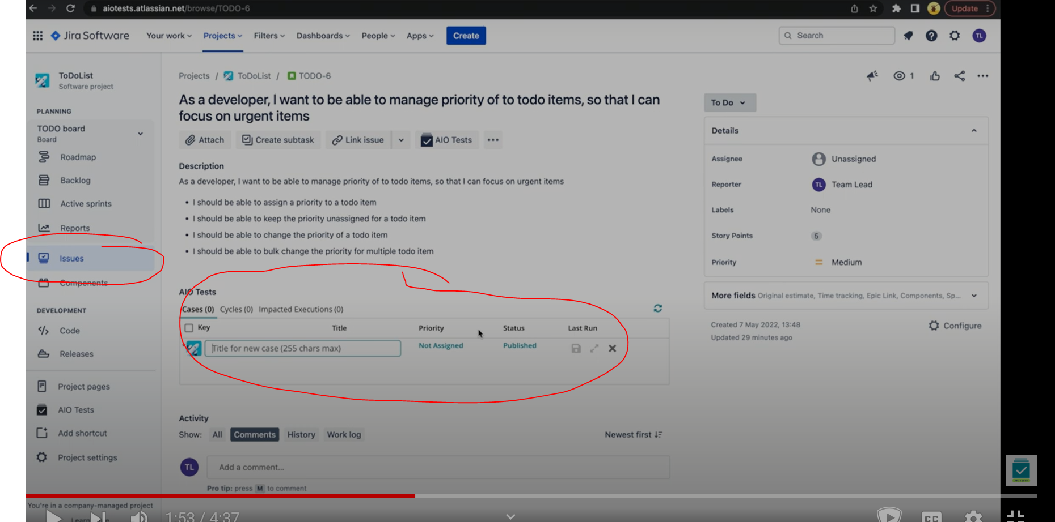

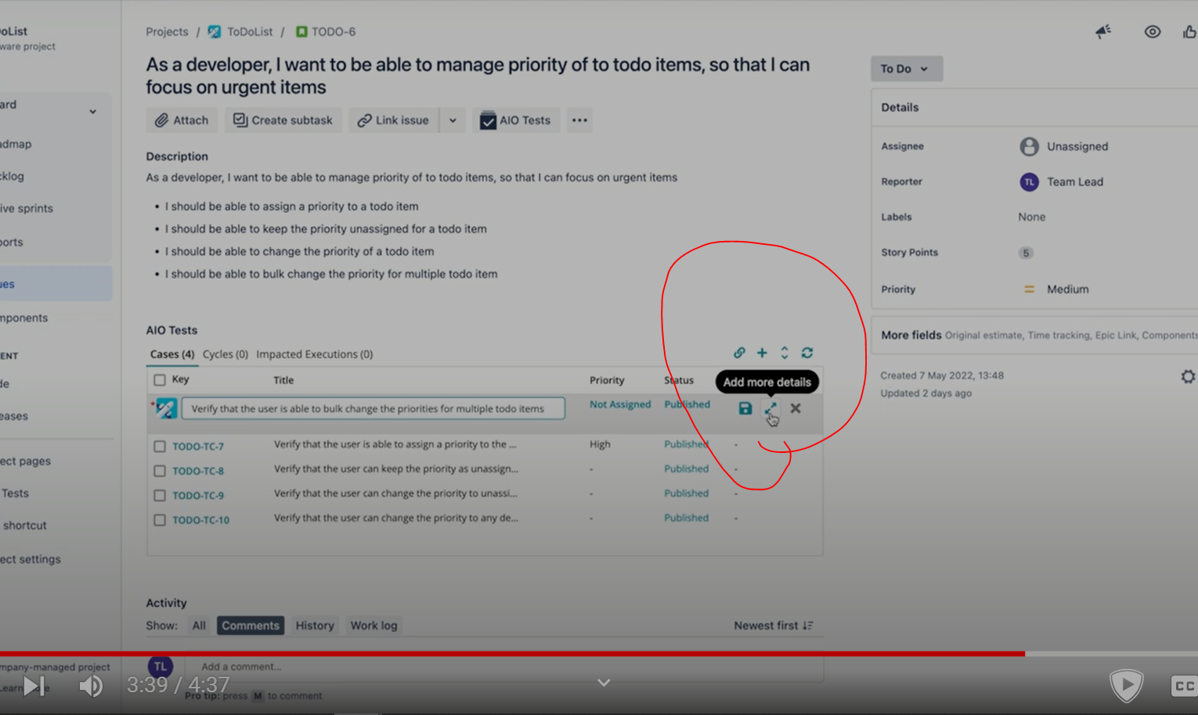

**Creating a folder**

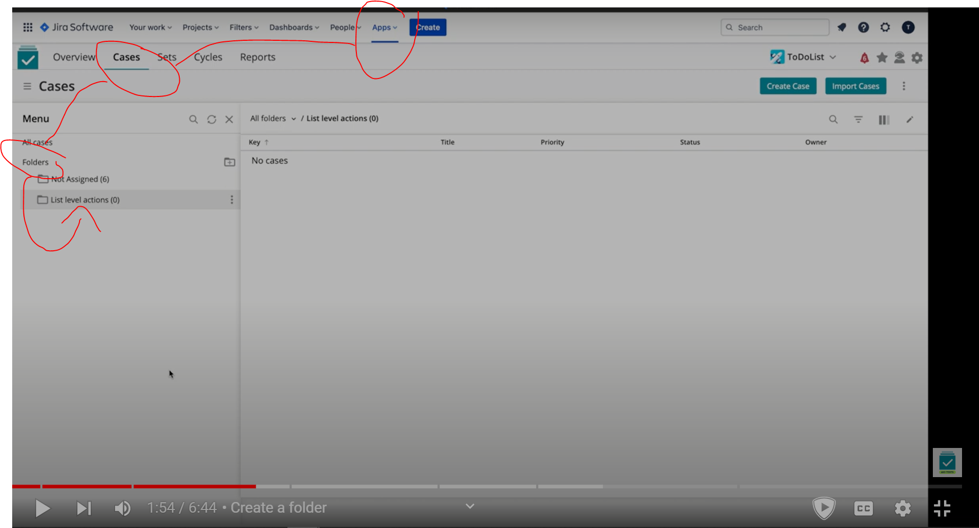

**2)Sub folder can also be made**

**3) bulk edit is also possible --- more than 1 test case is selected and moved or …..**

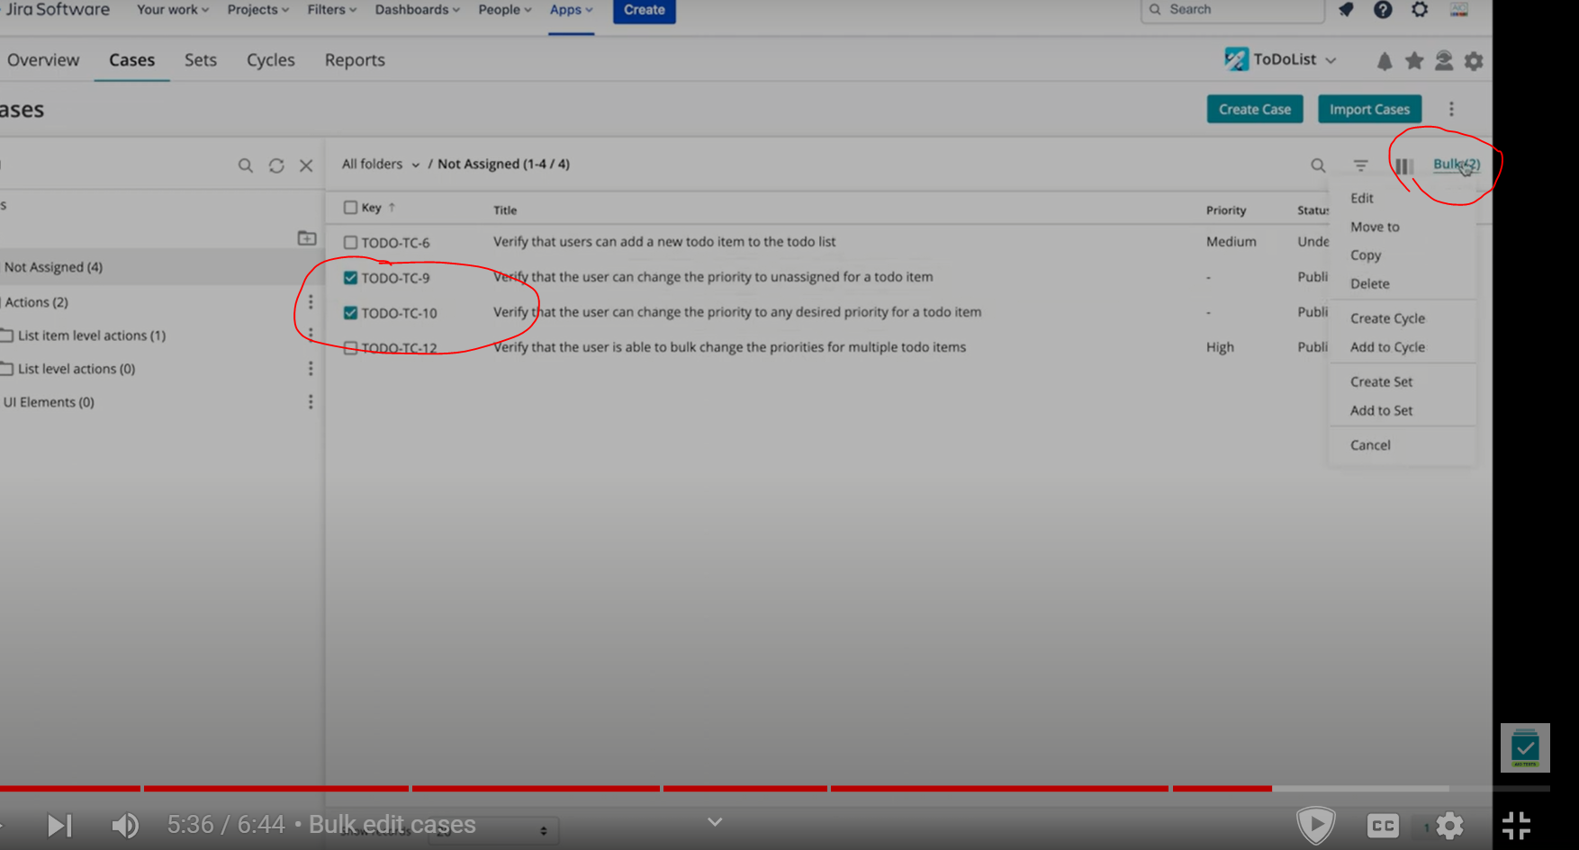

**4) copy test cases**

